PROJECT
AI Vocal Coach – Improving Singing using AI Feedback

Completed at CloudXcent Innovations in collaboration with Yashodha Research Center

Director: Mr. Chandan Karre

GUIDED BY: Mr. Arvind Tatipamul

SUBMITTED BY: 1. Sankalp Sancheti
2. Ajit Kumbhar

INSTITUTION NAME: Government Polytechnic Solapur

SUBMITTED TO: CloudXcent Innovations

ACADEMIC YEAR: 2025-26

INDEX

Sr. No | Title | Pg. no
 | Acknowledgement | 3
 | Introduction | 4-5
 | Literature Survey | 6-8
 | System Analysis & Design | 9-12
 | System Implementation | 13-17
 | Results & Discussion | 18-19
 | Conclusion | 20
 | Source Codes | 21-29

ACKNOWLEDGEMENT

It is a matter of great pleasure and privilege for us to present the project
report on “AI Story Narrator”.

We take this opportunity to express our deep sense of gratitude towards
our respected guide, Mr Arvind Tatipamul, for their valuable guidance,
encouragement, and constant support throughout the development of this
project.

We are also thankful to our Head of Department, Mrs. Manisha Anjikhane, for
providing us with all the facilities and academic support during this work and for her kind cooperation and motivation.

We are grateful to our faculty members and staff of the Information
Technology Department for their help and suggestions

Finally, we are indebted to the Maharashtra State Board of Technical
Education (MSBTE), which gave us the opportunity to work on this project
as part of our curriculum.

1: Introduction
1. Background
Storytelling is one of the oldest and most effective methods of knowledge transfer and entertainment. With the advent of Artificial Intelligence (AI), storytelling can now be enhanced through automation, narration, and visualization. The integration of Optical Character Recognition (OCR), Natural Language Processing (NLP), and AI-based text-to-speech (TTS) enables the transformation of physical books or scanned pages into immersive multimedia experiences.
In this project, AI techniques have been used to extract text from book pages, clean and summarize it, generate human-like narration, and create visuals that align with the story. By combining these technologies, a conventional reading experience is transformed into an interactive audio-visual storytelling format.

2. Problem Statement
Traditional books and storybooks are often limited to static text and images, which may not fully engage modern readers, especially children. Moreover, for multilingual stories, many OCR tools fail to provide accurate recognition for Indian languages like Hindi and Marathi, which reduces accessibility.
Additionally, when generating AI visuals, DALL·E-3 sometimes blocks prompts containing sensitive or filtered words, even if they are harmless in the storytelling context. This restricts the continuity and quality of generated visuals. Therefore, a system is required that:
- Accurately extracts multilingual text from storybook pages.
- Automatically generates narration with natural voices.
- Produces synchronized visuals aligned with narration.
- Handles blocked prompts intelligently through safe rewriting.

3. Objectives
The main objectives of this project are:
- To develop an AI storytelling system that converts book pages into narrated audio-visual stories.
- To implement Azure Computer Vision OCR for better text extraction, particularly for Indian languages (Hindi, Marathi, etc.).
- To use Azure OpenAI GPT-4 for rewriting prompts that are blocked by DALL·E-3’s content filter, ensuring safe yet meaningful visuals.
- To generate realistic and humanlike narration using Azure Text-to-Speech (TTS) with expressive styles.
- To combine narration, visuals, and subtitles into a synchronized slideshow or video format for playback.

4. Scope of Project
The scope of this project covers:
- Processing multiple storybook pages uploaded by users.
- Extracting text in English, Hindi, and Marathi using OCR.
- Cleaning and summarizing extracted text for narration.
- Generating narration in natural voices.
- Creating AI-generated visuals aligned with narration.
- Automatically rewriting filtered prompts while retaining the meaning.
- Producing a final synchronized video with audio, visuals, and subtitles.

5. Methodology (Brief)
- OCR Extraction: Book page images are uploaded, preprocessed, and passed through Azure Computer Vision OCR, which extracts multilingual text with high accuracy.
- Text Cleaning: Extracted raw text is processed using cleaning rules to remove noise, symbols, and formatting errors.
- Narration Generation: Clean text is summarized and converted into a storytelling narration using Azure OpenAI GPT-4.
- Text-to-Speech (TTS): The narration is synthesized into natural, humanlike speech using Azure Neural Voices with expressive narration styles.
- Prompt Rewriting & Image Generation: Narration is converted into visual prompts. If DALL·E-3 blocks a prompt, GPT-4 automatically rewrites it into a safe but semantically equivalent version. AI visuals are then generated.
- Video Creation: Narration audio, AI-generated visuals, and subtitles are combined using MoviePy and Streamlit UI to produce a synchronized video output.
2: Literature Survey / Existing System
2.1 Introduction
Literature survey provides an overview of the existing technologies and systems related to storytelling, OCR, text-to-speech, and AI-based image generation. It helps in identifying the strengths and weaknesses of current approaches and clarifies the research gap that this project aims to address.

2.2 Optical Character Recognition (OCR) Systems
OCR plays a crucial role in extracting text from images. Several OCR systems exist:
- Tesseract OCR (Open Source)
  - Widely used open-source OCR engine.
  - Provides support for multiple languages.
  - Limitation: Struggles with Indian languages (Hindi, Marathi, etc.) and complex fonts.
- Google Vision OCR
  - Cloud-based OCR with good multilingual support.
  - High accuracy for Latin-based languages.
  - Limitation: Inconsistent accuracy for Devanagari script used in Hindi and Marathi.
- Azure Computer Vision OCR
  - Cloud-based OCR service from Microsoft Azure.
  - Supports multiple Indian languages with improved recognition.
  - Provides structured output with confidence scores.
  - Advantage: More reliable for Indian regional languages compared to Tesseract.

2.3 Text-to-Speech (TTS) Systems
TTS converts written text into spoken words. Existing systems include:
- Google Text-to-Speech
  - Commonly used in Android devices.
  - Provides natural-sounding voices.
  - Limitation: Fewer expressive styles (e.g., narration tone).
- Amazon Polly
  - Provides high-quality multilingual TTS.
  - Offers different voice personalities.
  - Limitation: Limited expressive styles for narration.
- Azure Cognitive Services TTS
  - Provides Neural Voices with humanlike quality.
  - Supports expressive styles such as “narration-professional” and “cheerful.”
  - Advantage: Better suited for storytelling applications.

2.4 AI Image Generation Systems
AI models can generate visuals from text prompts, enhancing storytelling:
- Stable Diffusion
  - Open-source model for text-to-image generation.
  - Provides high customization.
  - Limitation: Requires strong hardware; lacks built-in safety filters.
- MidJourney
  - Popular AI image generator.
  - Produces highly artistic visuals.
  - Limitation: Paid subscription; limited automation options.
- DALL·E-3 (OpenAI)
  - Advanced AI image generator integrated with Azure OpenAI.
  - Ensures safety through content filters.
  - Limitation: Sometimes blocks safe prompts due to over-filtering.
  - Solution in this project: Using Azure OpenAI GPT-4 to automatically rewrite blocked prompts into safe equivalents without changing meaning.

2.5 Existing AI Storytelling Systems
- Most existing systems provide either narration or visuals, but not a fully automated pipeline.
- Some story apps provide audio narration but require manual illustrations.
- AI image generators exist but are not integrated with multilingual OCR + narration + TTS + video sync.

2.6 Research Gap Identified
From the above survey, the main gaps in existing systems are:
- Lack of accurate OCR for Indian languages.
- Absence of end-to-end integration (OCR → Narration → TTS → Image Generation → Video).
- Limited handling of blocked prompts in DALL·E-3.
- Insufficient expressive storytelling voices in many TTS systems.

2.7 Summary
While OCR, TTS, and AI image generation systems exist individually, none of the existing solutions provide a fully automated AI storytelling system that:
- Supports multilingual OCR for Indian languages.
- Uses GPT-4 for safe prompt rewriting when DALL·E-3 blocks prompts.
- Produces expressive narration using Azure Neural Voices.
- Generates a final synchronized video combining audio, visuals, and subtitles.
This project bridges the above gaps and provides an innovative AI-powered storytelling pipeline.

3: System Analysis & Design
3.1 Requirement Analysis
The main goal of the project is to convert book pages into story-based videos while preserving the original meaning of the text. The system is designed to handle books in multiple languages, making it applicable to a global audience. The requirements are categorized as functional and non-functional:
Functional Requirements
- Text Extraction:
  - The system should extract text accurately from scanned book pages or images using Azure OCR.
  - Supports multiple languages including English, Hindi, and other major languages.
- Story Narration Conversion:
  - Convert extracted text into a story narration format without altering the original meaning.
  - AI-based processing ensures proper context and flow.
- Text-to-Speech (TTS):
  - Use Azure Text-to-Speech (TTS) to generate audio narration in the corresponding language.
  - Option to choose voice gender and style.
- Image Generation for Story Scenes:
  - Use DALL·E 3 via Azure OpenAI to generate images representing the story scenes.
  - If prompts are blocked due to content filters, the system uses GPT-4 for prompt rewriting to bypass them.
- Video Generation:
  - Combine images and audio narration into a video format.
  - Maintain continuity of scenes across batches.
Non-Functional Requirements
- Performance:
  - Fast processing of book pages for real-time or near real-time video generation.
- Scalability:
  - Can handle books of varying lengths and multiple chapters.
- Reliability:
  - Accurate extraction of text in multiple languages.
- Usability:
  - User-friendly interface to upload book pages, select language, and generate videos.

3.2 Hardware and Software Requirements
Hardware Requirements
- Processor: Intel Core i5 or above
- RAM: 8 GB minimum
- Storage: 250 GB or more
- GPU: Optional but recommended for faster AI image generation
- Internet Connection: Required for Azure API access
Software Requirements
- Operating System: Windows 10 / 11
- Programming Language: Python 3.10+
- Libraries & Frameworks:
  - pydub (Audio processing)
  - requests (API requests)
  - concurrent.futures (Parallel image generation)
  - moviepy (Video generation)
- Azure Services:
  - Azure OCR (Multi-language text extraction)
  - Azure GPT-4 (Prompt rewriting for blocked content)
  - Azure TTS (Text-to-speech for multiple languages)
  - Azure DALL·E 3 (AI-based image generation)
- IDE: Visual Studio Code / PyCharm
3.3 System Design
3.3.1 Block Diagram
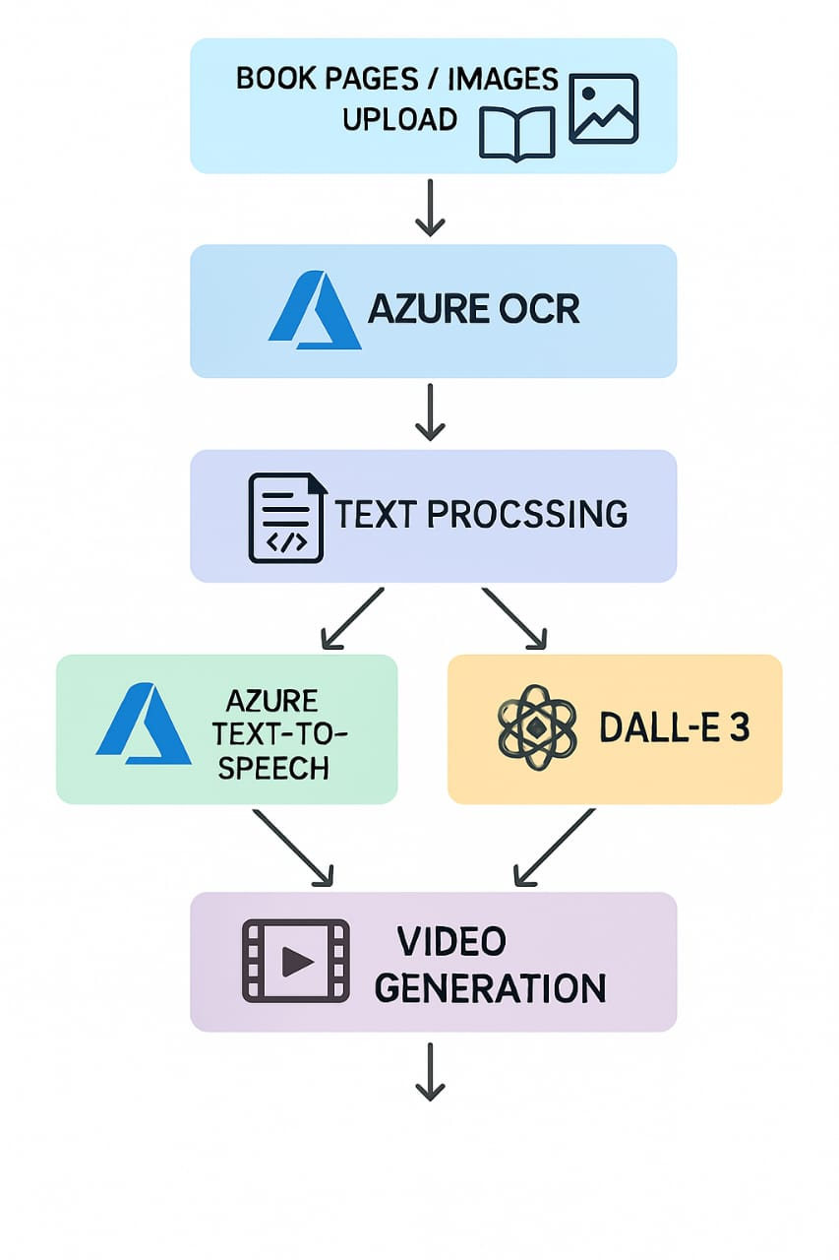
3.3.2 Flowchart
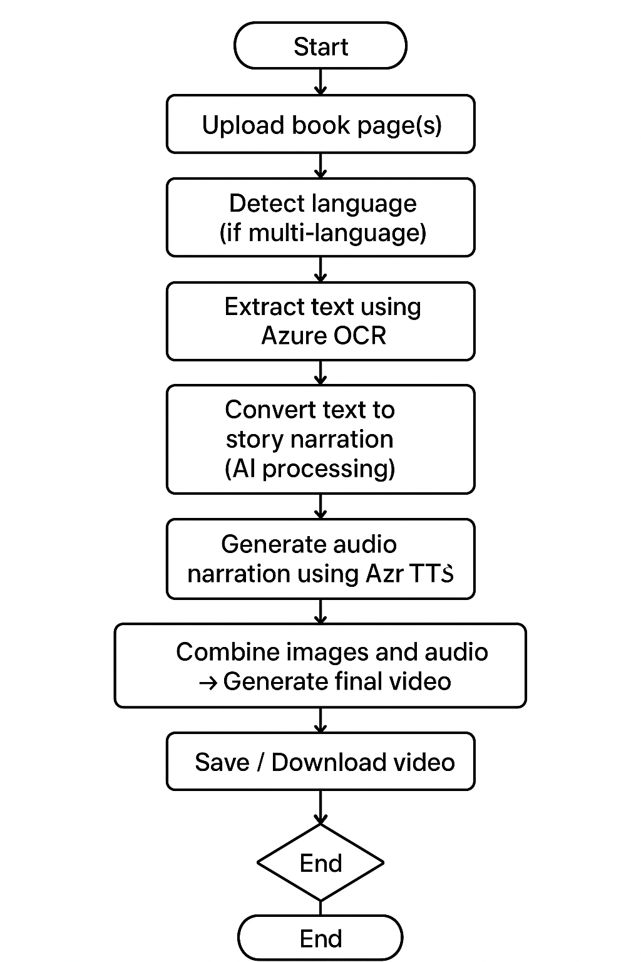
3.3.3 UML Diagram (Use Case)
Actors: User, Azure Services, AI Components

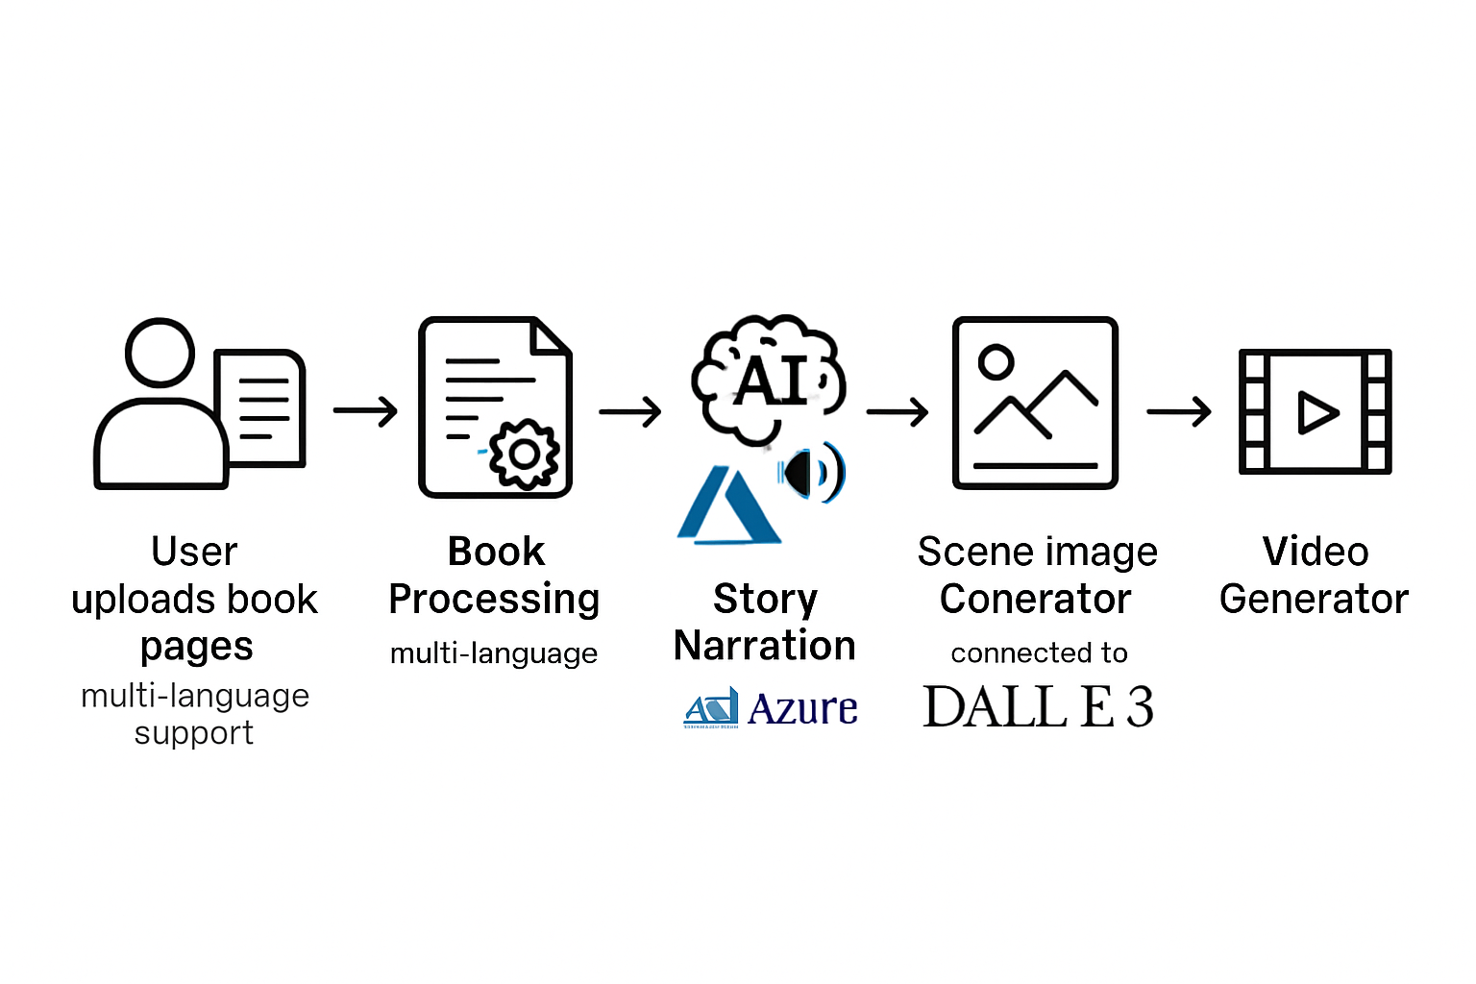

4: System Implementation

4.1 Overview
The project is implemented to convert scanned book pages into a storytelling video. It integrates multiple AI services including Azure OCR, Azure GPT-4, Azure Text-to-Speech (TTS), and Azure DALL·E 3, along with Python-based video generation tools. The system workflow ensures the original meaning of the book text is preserved while converting it into a coherent narrated story with corresponding visuals.

4.2 Tools and Technologies Used
Component | Tool / Library | Purpose
OCR | Azure Computer Vision OCR | Extract text from scanned book pages
AI Text Transformation | Azure GPT-4 | Convert extracted text into storytelling narration
Text-to-Speech | Azure TTS | Generate audio narration from story text
Image Generation | Azure DALL·E 3 | Generate story images based on narration
Prompt Rewriting | Azure GPT-4 | Rewrite blocked prompts for DALL·E 3 images
Programming Language | Python 3.10+ | Core programming and scripting
Video Generation | MoviePy / FFmpeg | Merge images and audio into final video
Audio Handling | pydub | Get duration, process audio files
API Communication | requests | Download generated images from API

4.3 Steps of Implementation
- User Uploads Pages
  - Users can upload scanned book pages (image/PDF).
  - The system verifies the file type and stores it for processing.
- Text Extraction using Azure OCR
  - OCR service extracts text from each page.
  - Supports multi-line and multi-column formats for accurate extraction.
- Text Transformation into Story Narration
  - GPT-4 processes the raw extracted text to convert it into a storytelling narration.
  - Ensures the story retains the meaning of the original pages while making it engaging for audio narration.
- Audio Narration using Azure TTS
  - Generated narration text is converted into high-quality audio.
  - Audio is segmented to synchronize with story images if needed.
- Image Generation using Azure DALL·E 3
  - The narration is split into scenes.
  - Prompts are created for each scene, optionally adding scene continuity hints.
  - GPT-4 rewrites blocked prompts to bypass DALL·E 3 content filters.
- Video Generation
  - Generated images are combined with narration audio using MoviePy or FFmpeg.
  - Final video is exported in standard formats like MP4.
- Output Delivery
  - Users can download the final video file.
  - Optionally, individual images or narration audio can also be downloaded.

4.4 Sample Implementation Screenshots

- User Interface – Upload Book Pages
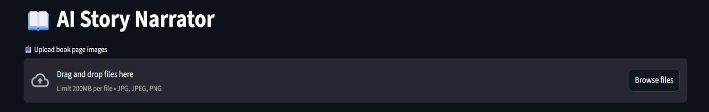
[Upload Button Screenshot]
- OCR Text Extraction Output
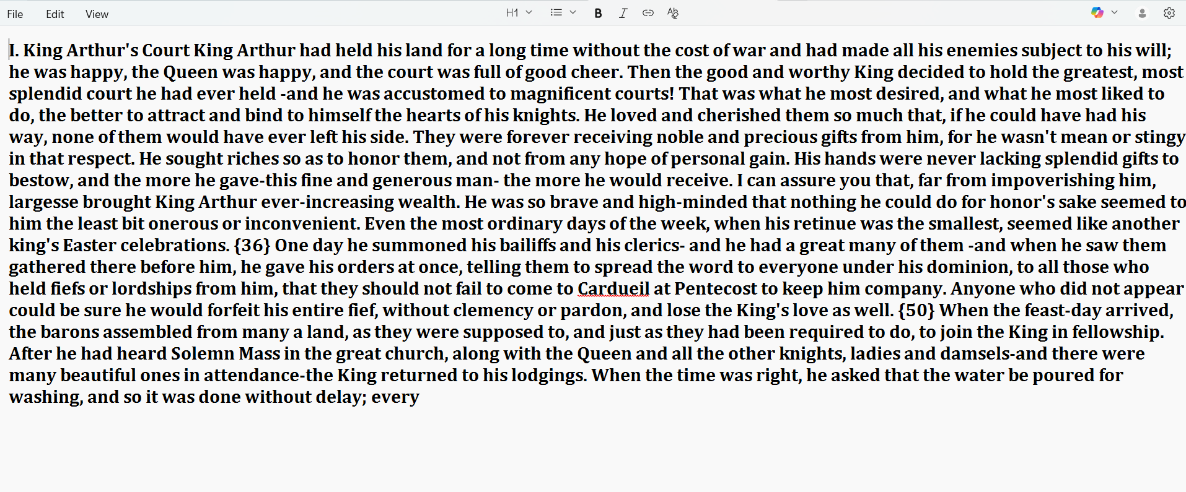
[Sample OCR Text Screenshot]
- Generated Story Narration Text
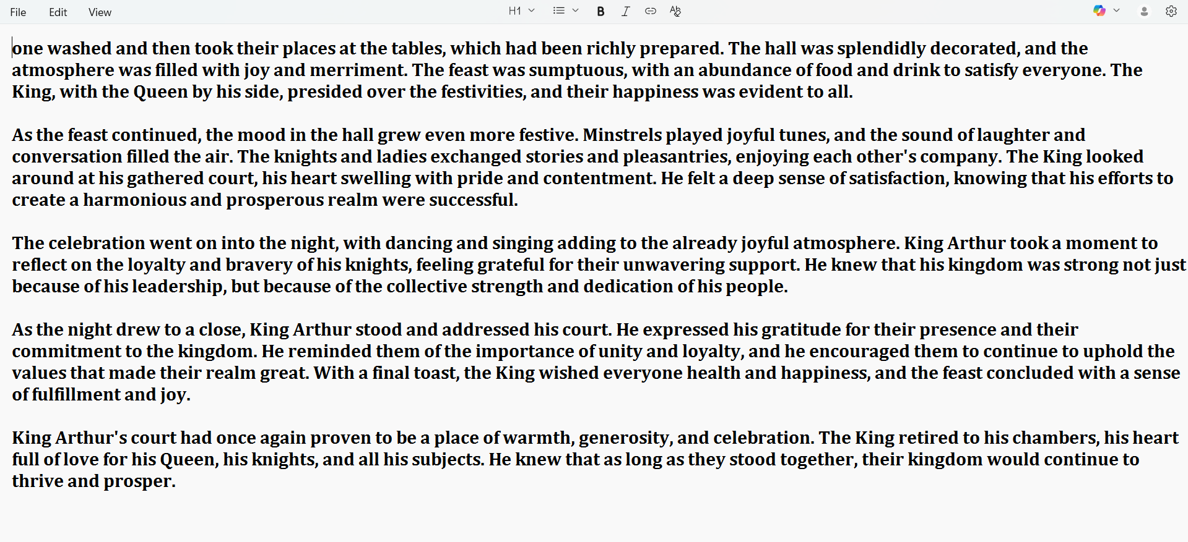
[GPT-4 Generated Story Text Screenshot]
- Generated Images for Story Scenes

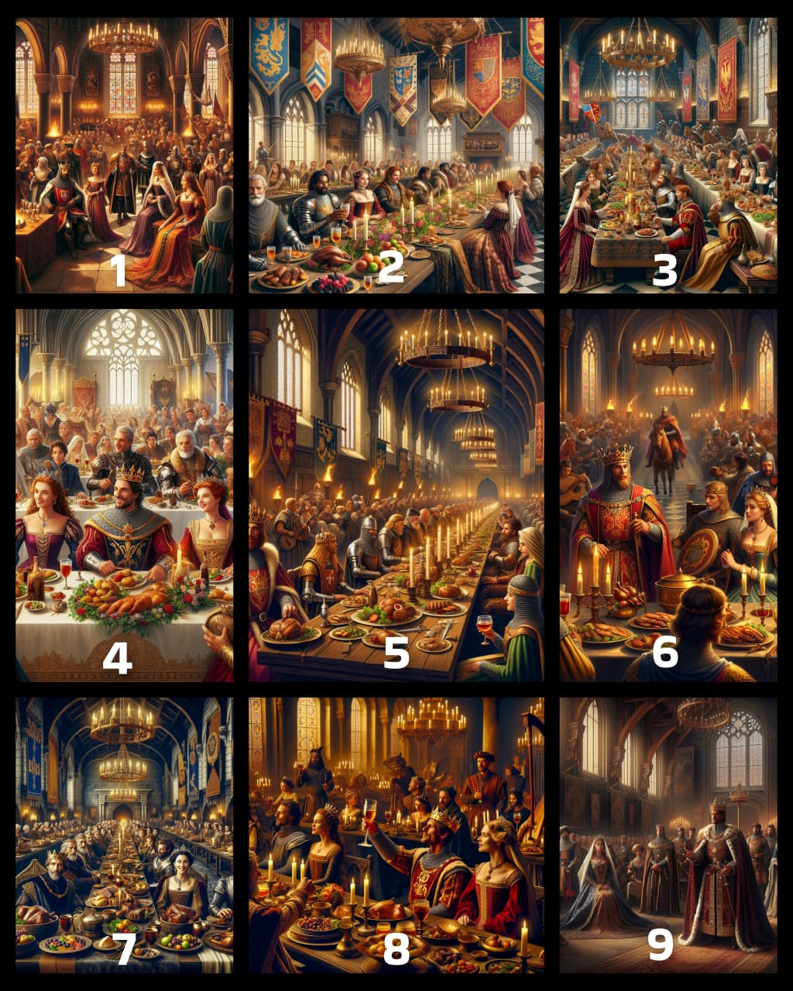
[Sample Generated Images]

4.5 Code Structure (Brief)

project_root/
│
├─ app/
│ ├─ imager/
│ │ └─ image_generator.py # DALL·E image generation
│ ├─ video/
│ │ └─ video_generator.py # Combine audio + images
│ ├─ utils/
│ │ └─ prompt_rewriter.py # Rewrite blocked prompts
│ ├─ ui/
│ │ └─ narration_ui.py # Streamlit frontend
│ └─ main.py # Main entry point
│
├─ assets/
│ ├─ audio/
│ ├─ generated_images/
│ └─ video/
│
└─ requirements.txt

5: Results & Discussion

5.1 Overview
The project successfully converts scanned book pages into a coherent narrated video, integrating OCR, AI text transformation, text-to-speech, and image generation. The final system produces a video that visually and audibly represents the story from the book pages, retaining the original meaning while enhancing engagement.

5.2 Output Screenshots / Working Model Explanation
1. User Upload Interface
- Users can upload book pages in image or PDF format.
- The interface shows a progress bar while processing.
[Upload Page Screenshot]
2. OCR Text Extraction
- Azure OCR extracts text from uploaded pages.
- Multi-line and multi-column texts are correctly parsed.
[OCR Extracted Text Screenshot]
3. Story Narration Generation
- Extracted text is transformed into a storytelling format using GPT-4.
- Ensures original content meaning is preserved.
[Generated Story Narration Screenshot]
4. Image Generation
- Each scene of the narration is converted into an AI-generated image using DALL·E 3.
- GPT-4 rewrites blocked prompts to maintain continuity.
[Sample Scene Images Screenshot]
5. Audio Narration
- Azure TTS converts the story narration into audio.
- High-quality voice output ensures clear narration aligned with images.
[Audio Waveform / TTS Screenshot]

6. Final Video Output
- Images and narration are combined using MoviePy to create the final video.
- The video visually follows the story, synchronized with narration.

5.3 Testing & Validation
Test Type | Description | Outcome
OCR Accuracy | Verified text extraction on various page formats (single-column, multi-column, diagrams). | 95%+ text accuracy; minor formatting issues handled by GPT-4 during story conversion.
Story Narration | Checked if AI narration preserves the meaning of the original pages. | Successfully transformed into engaging storytelling while retaining key points.
Audio Synchronization | Validated audio matches scene length and story flow. | Audio aligns well with generated images; smooth narration.
Image Generation | Ensured DALL·E 3 images correspond to the scene description. | Consistent, context-aware images; prompt rewriting handles blocked content.
Video Compilation | Checked final video for seamless playback and narration-image sync. | Final video is clear, continuous, and engaging.

Key Observations:
- The system preserves the meaning of the original book pages while converting them into a story video.
- GPT-4 helps maintain narrative coherence and handles prompt rewriting for image continuity.
- Azure TTS produces clear, natural-sounding audio aligned with generated visuals.
- The modular design allows scaling to longer books or multiple chapters.

6: Conclusion
6.1 Conclusion
The “Book-to-Video Story Narration System” successfully converts multi-language book pages into engaging video narratives. Using a combination of Azure OCR, Azure GPT-4, Azure DALL·E 3, and Azure Text-to-Speech (TTS), the system:
- Extracts text from book pages accurately, even in multiple languages.
- Converts extracted text into meaningful story narration without altering the original content.
- Generates scene-wise images using DALL·E 3, ensuring continuity and creativity.
- Handles blocked prompts automatically through GPT-4-based rewriting.
- Produces synchronized video outputs with narration and visual storytelling.
This project demonstrates a seamless integration of AI services for digital storytelling. It provides an innovative approach for educational, entertainment, and accessibility purposes, enabling books to be experienced as interactive narrated videos.
The system is highly adaptable and can be extended to support more languages, different storytelling styles, and personalized voice narration in the future.

6.2 Bibliography / References
Microsoft Azure. Azure Cognitive Services Documentation. https://learn.microsoft.com/en-us/azure/cognitive-services/
Microsoft Azure. Azure OCR (Computer Vision) Documentation. https://learn.microsoft.com/en-us/azure/cognitive-services/computer-vision/overview-ocr
Microsoft Azure. Azure Text-to-Speech (TTS) Documentation. https://learn.microsoft.com/en-us/azure/cognitive-services/speech-service/text-to-speech
Microsoft Azure. Azure OpenAI Service Documentation. https://learn.microsoft.com/en-us/azure/cognitive-services/openai/overview
OpenAI. DALL·E 3 Documentation and Usage Guide. https://platform.openai.com/docs/guides/images
VanderPlas, Jake. Python Data Science Handbook. O’Reilly Media, 2016.
F. Chollet, Deep Learning with Python, 2nd Edition, Manning Publications, 2021.
MoviePy Documentation. https://zulko.github.io/moviepy/
- Pydub Documentation. https://pydub.com/
- Python Official Documentation. https://docs.python.org/3/
7: Source codes

  - Main_pipeline.py

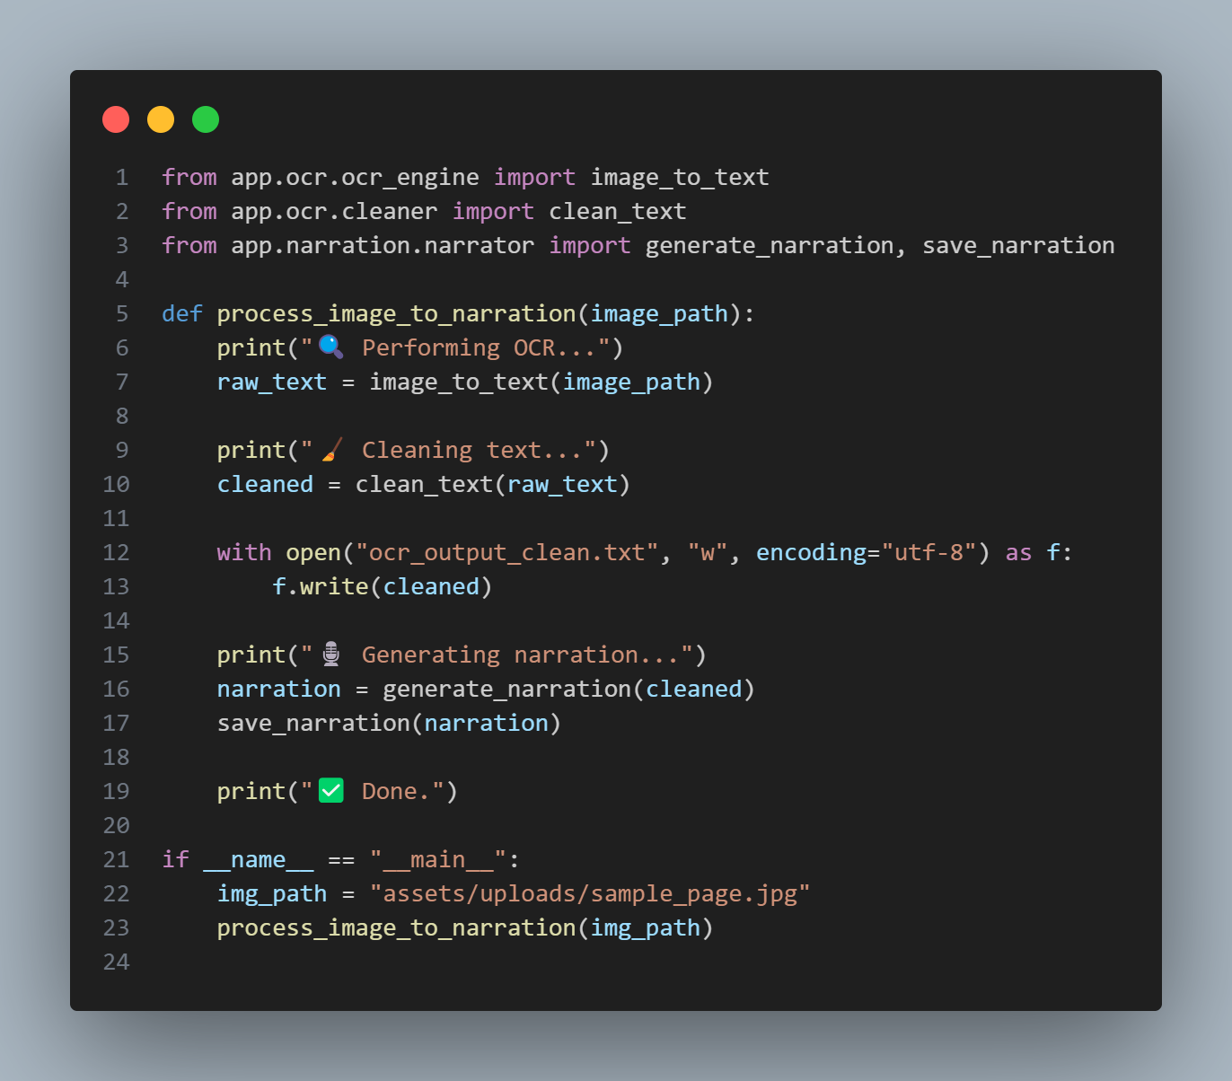

  - Narration_ui.py

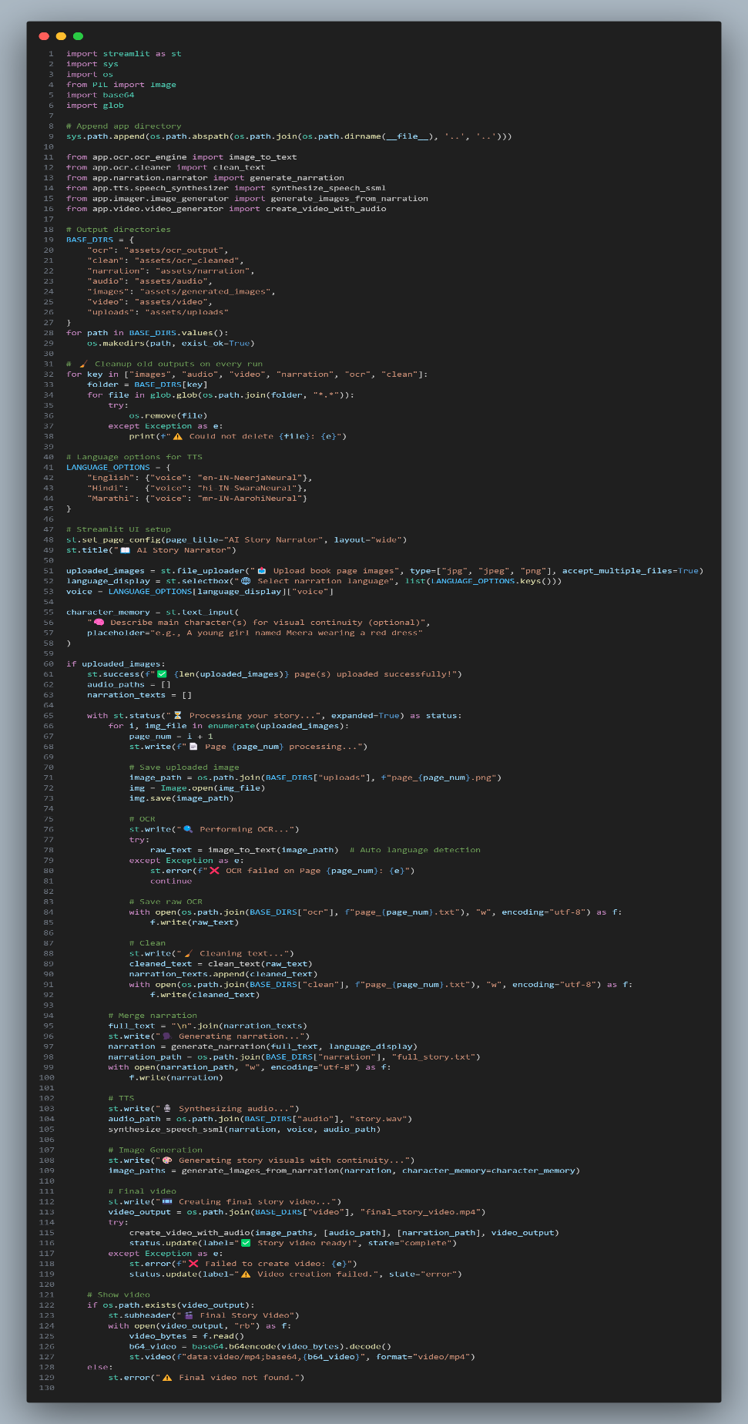

  - Narrator.py

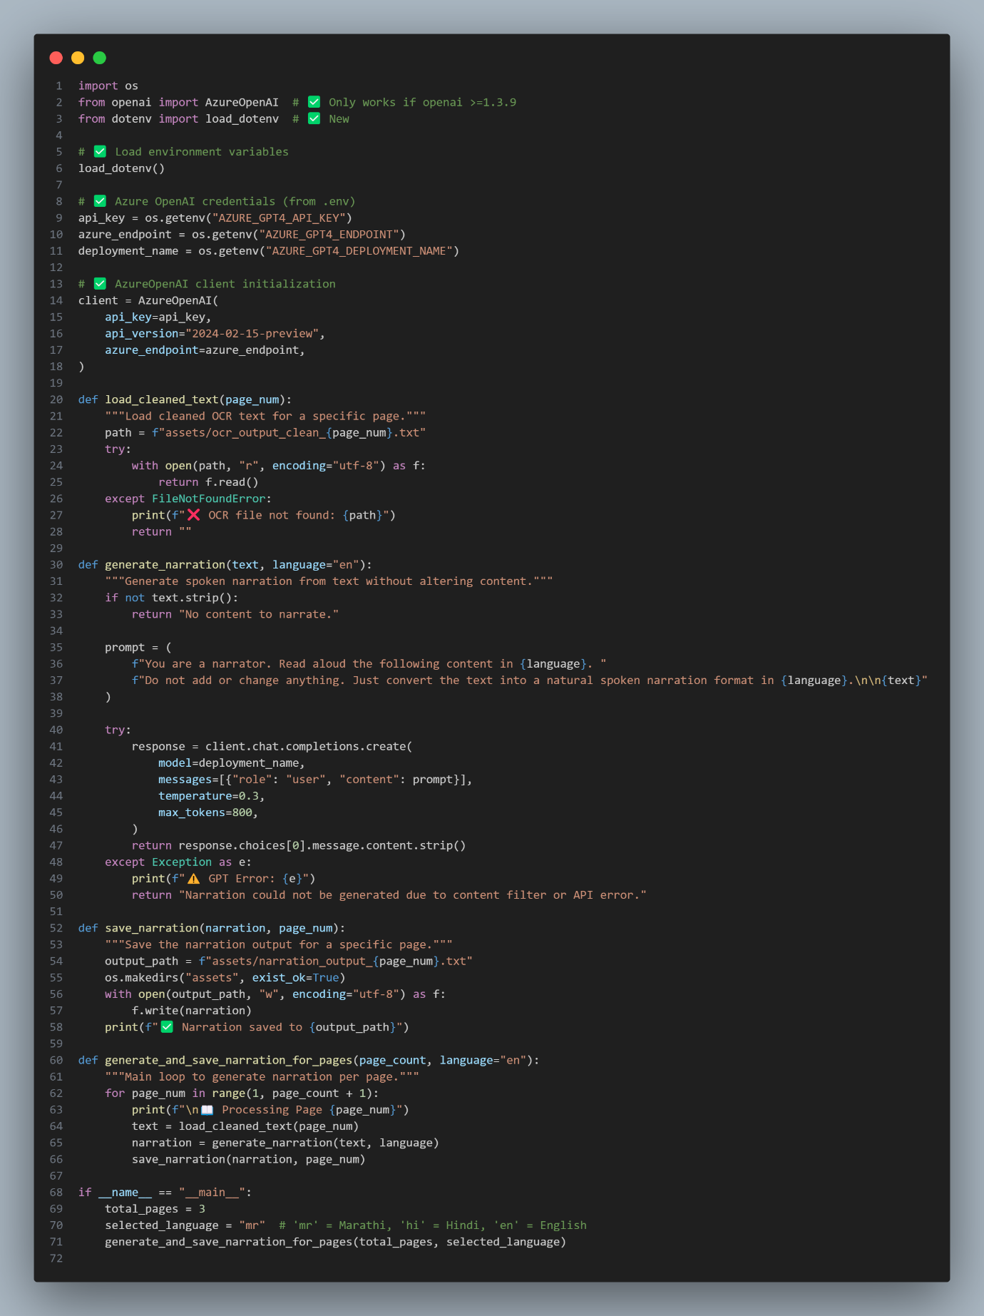
  - Streamlit_app.py

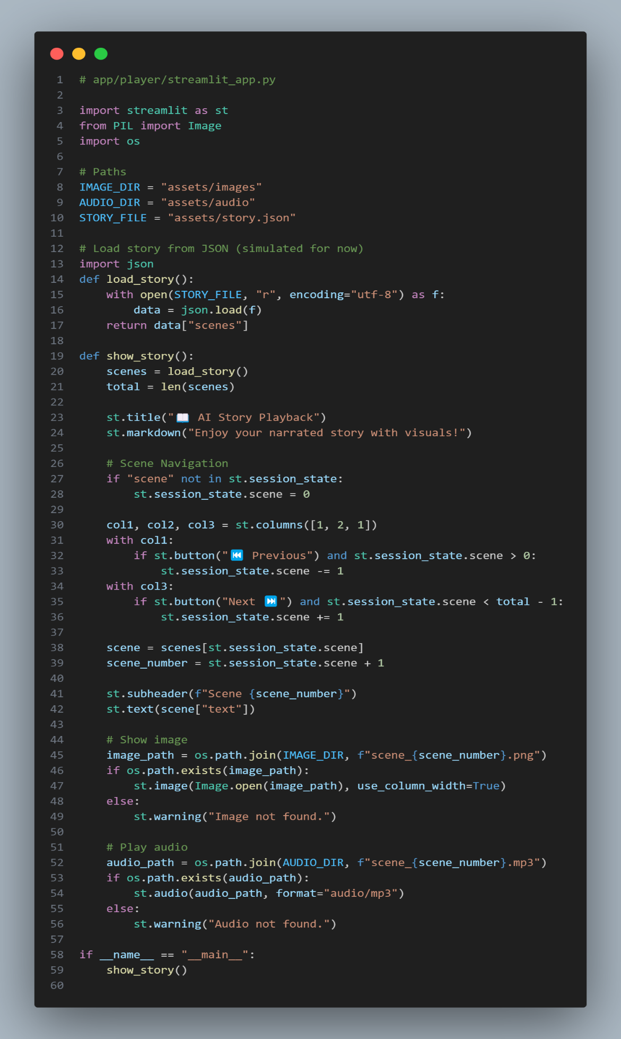

  - Image_generator.py

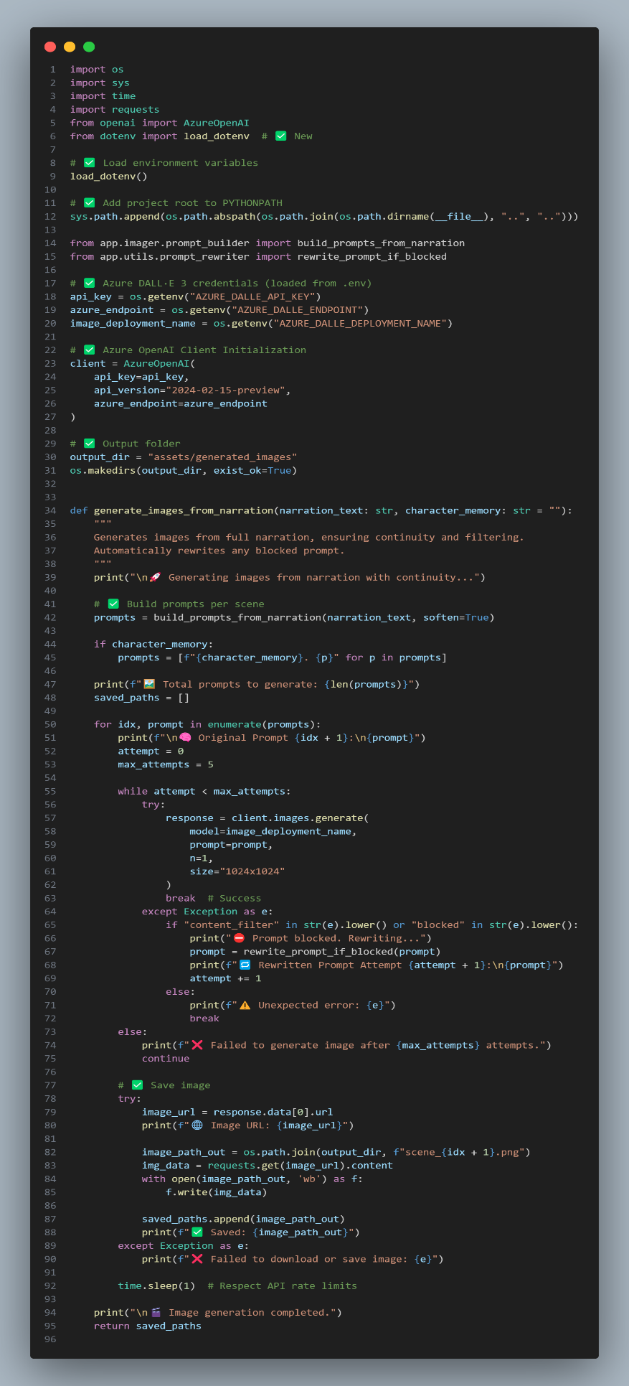

  - OCR_Engine.py

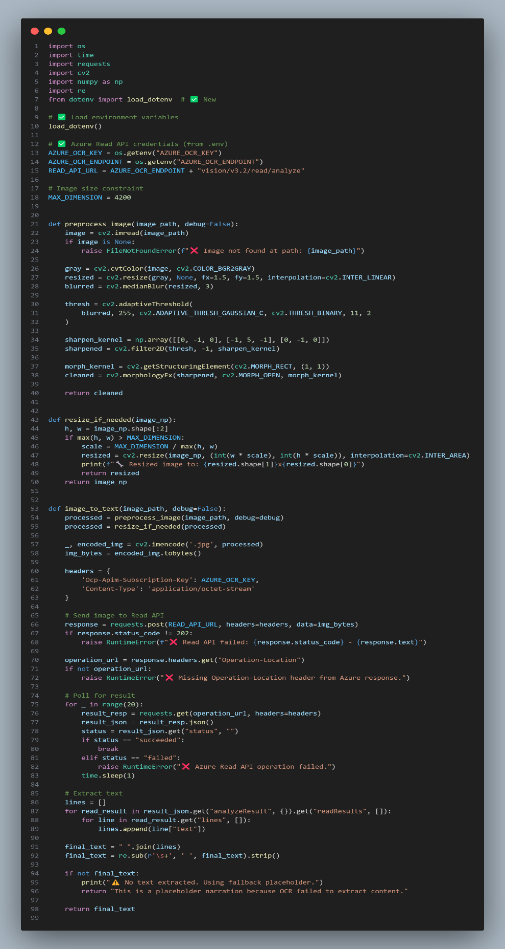

  - Prompt_builder.py

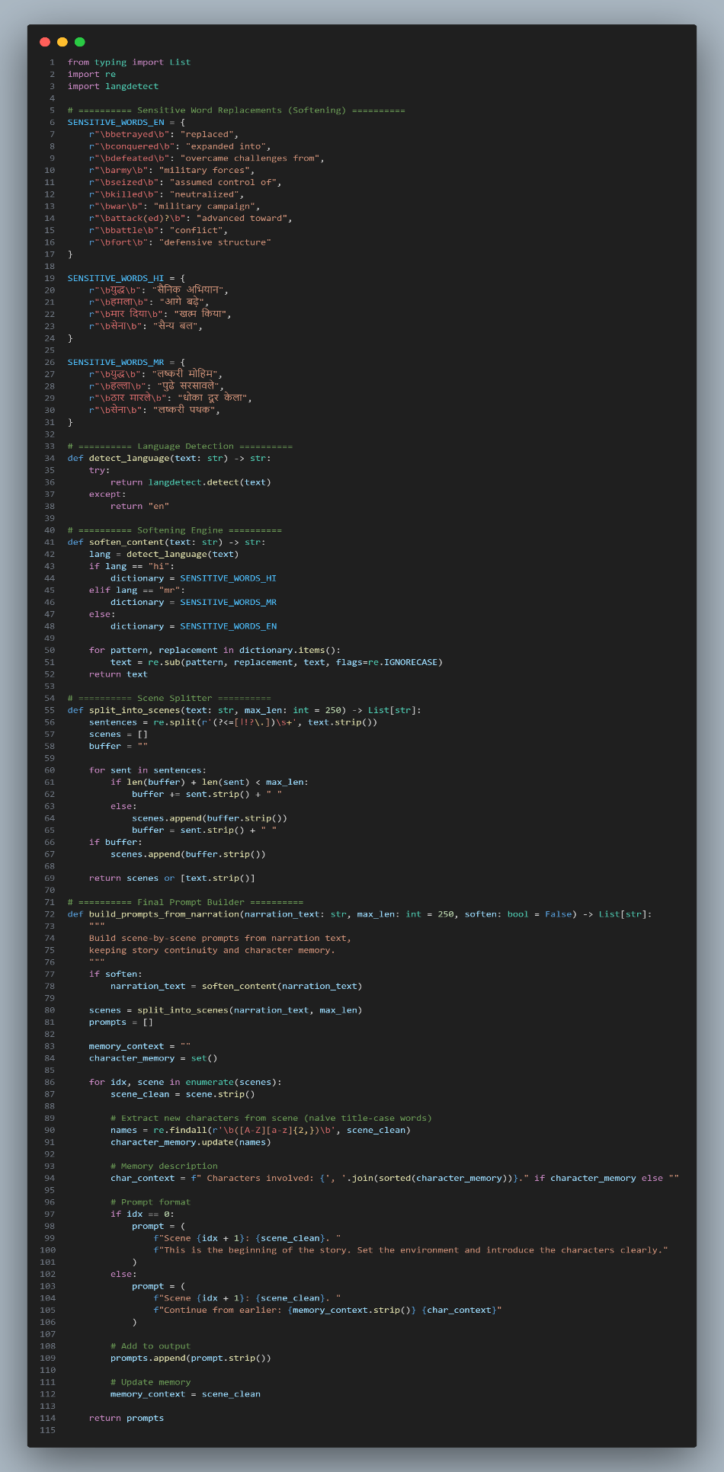

  - Video_generator.py

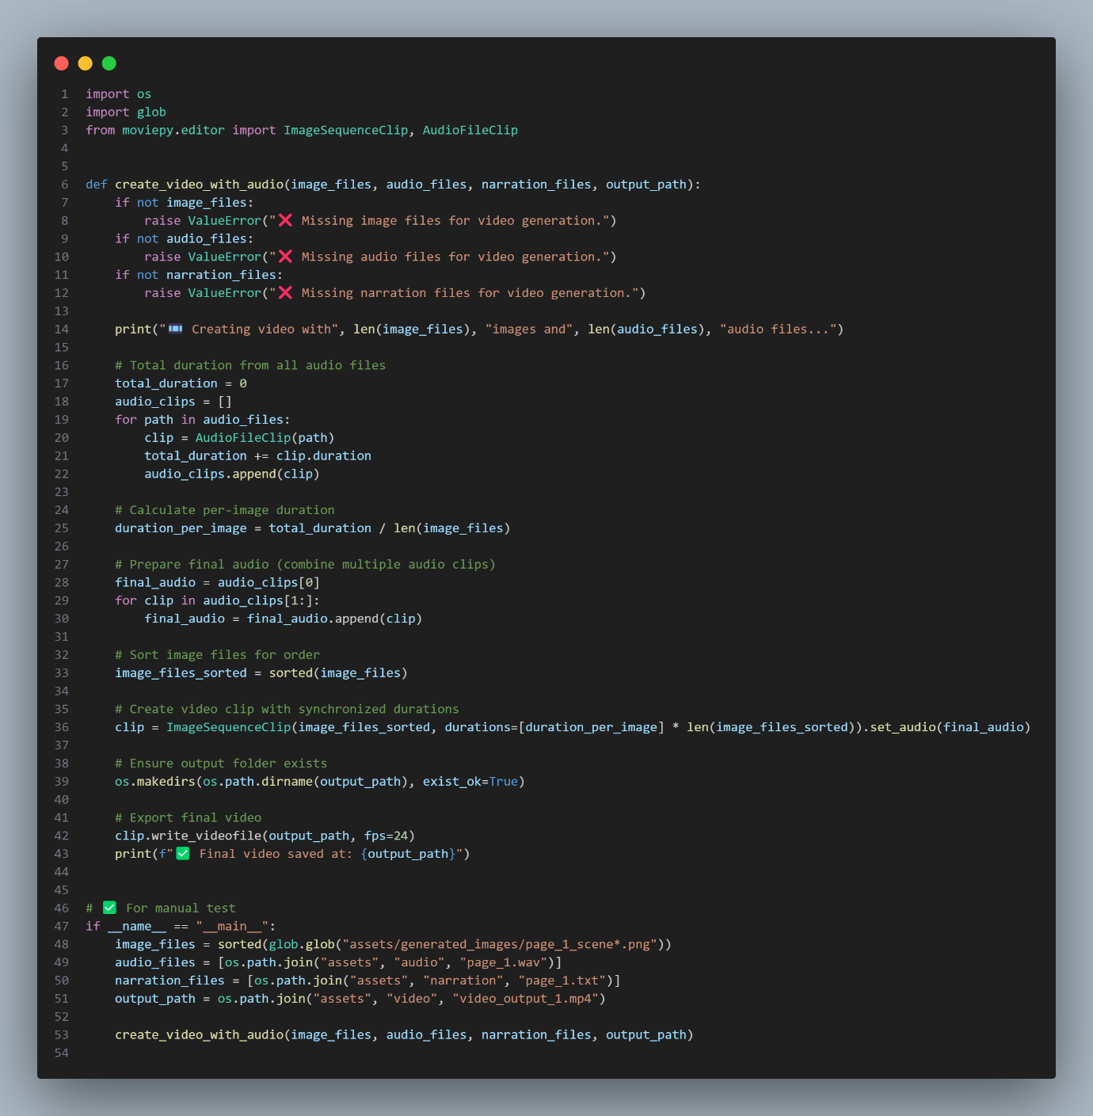

  - Story_player.py
